Zerto’s vCD Tenant UI Plugin Guide:

ZVR 8.5 introduced compatibility with vCD’s Tenant UI, which enabled the provider to leverage VMware’s Tenant UI as their Self-Service Portal versus Zerto’s native ZSSP. This gives the user a choice between the two portals for user access. Leveraging the Tenants UI allows the provider to grant the end-user the same capabilities in the Tenant’s UI, but with a Zerto facelift via the Zerto Tenants UI Plugin.

To leverage Zerto’ vCD Tenants UI Plugin feature, you will need to download the plugin from myzerto.com and follow these steps below:

Zerto Tenant UI Plugin Prerequisites:

* Environmental Prerequisites:
  + ZVMs are installed on VCs
  + ZCM is installed
  + ZVM sites are added
  + VCD is installed
  + VCD Organizations are created
* Zerto vCD Plugin Manager:
  + The dedicated tool ZertoVcdPluginManager is required to automatically install the custom Zerto plugin on the VCD site. The tool can be downloaded from the MyZerto portal’s [downloads page](https://www.zerto.com/myzerto/support/downloads/).

Installation Process:

Here are the steps that a user will need to perform during the installation of the tool:

1. Login to the ZCM

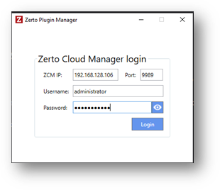

1. Update the ZVM site names as they should be displayed on the Tenant UI view
2. Input the VCD IP and credentials
3. Click the ‘Install Plugin’ button and the ZVM VCD Plugin installation will begin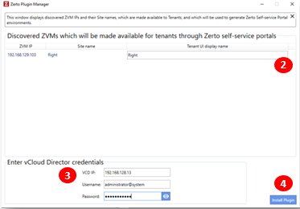

Configuring Zerto VCD Plugin:

1. Login to VCD as an Administrator

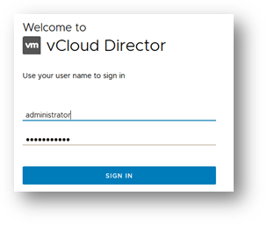

1. Go to the Customize Portal view

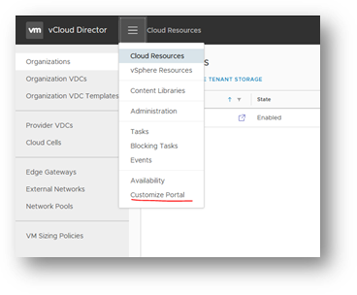

1. Select the Zerto Tenant Plugin and click Publish

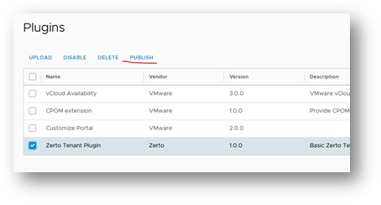

1. Uncheck Service Providers and check Tenants where you want the Plugin to be turned on

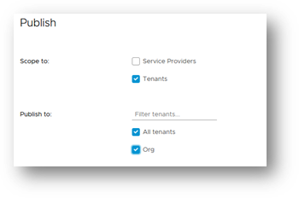

1. Click Save

Zerto VCD Plugin Tenant view:

1. Login as a Tenant or simply navigate to the Tenant view

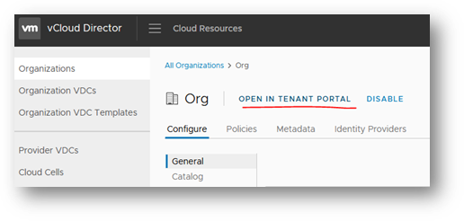

1. Click the Dropdown Menu and select Zerto.
   * A view is opened with the ZSSP links to the sites which contain resources that were assigned to the Tenant. This is commonly a single link. If a problem occurs while generating a link, an error should appear while hovering over the link button.

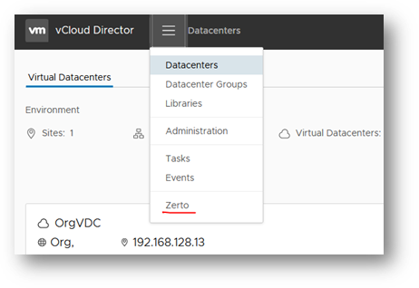

1. Click on the link
2. A new browser tab will open, logging in to the ZSSP automatically on the behalf of a ZSSP user.
   * **Note:** The session might expire if idle for some time. To refresh it, simply refresh the Zerto Plugin Tenant view and click the link again.

Considerations – *Subject to change

Known issues:

* If a customer has upgraded his environmental Orgs, VCenter, ZVMs – he should reinstall the new plugin. The reinstall actions are similar to the first time install. This is currently a known limitation of the feature.

Limitations:

* If a customer wishes to add the organization or reassign the resources, they will need to republish the plugin after they make those changes. This means that they will need to run the tool and perform the installation steps again. If a customer forgets to do this, the ZVM Tenant view will not display their last changes.

Troubleshooting:

* The tool logs are available under the *‘\logs’*folder